Name: Meagan Hise
Grade Level: 1st
Content Area: Math
Basic Productivity Tool Used: Graph Club
Standards Addressed: MCC1.MD.4 Organize, represent, and interpret data with up to three categories; ask and answer questions about the total number of data points, how many in each category, and how many more or less are in one category than in another.
Bloom’s Level of Critical Thinking:
Remembering Understanding Applying Analyzing Evaluating Creating
Description of how to implement in the class: With these spreadsheets students will make their own statistical poll of their choice by asking either classmates, friends, or family opinions. They will then pick any topic from favorite ice cream flavor to favorite animal but they at least have to offer three choices of that chosen item. Once they have taken their poll they will then make two charts of their choice, whether circle graph, line graph, picture graph, or etc., to show their polls statistics. They will then present their charts to the class.
Level of Technology Implementation (LoTi): Level 5 expansion because students are fully engaged and are exploring real-world issues. Students are using experimental inquiry and problem solving to answer student generated questions.
Description of the sample spreadsheet and graph/chart provided *: My chart is an example of how one statistical poll should look. I have three or more options put into an understandable and organized chart. Students can use mine as a one of their chart examples of how there finish product should look.

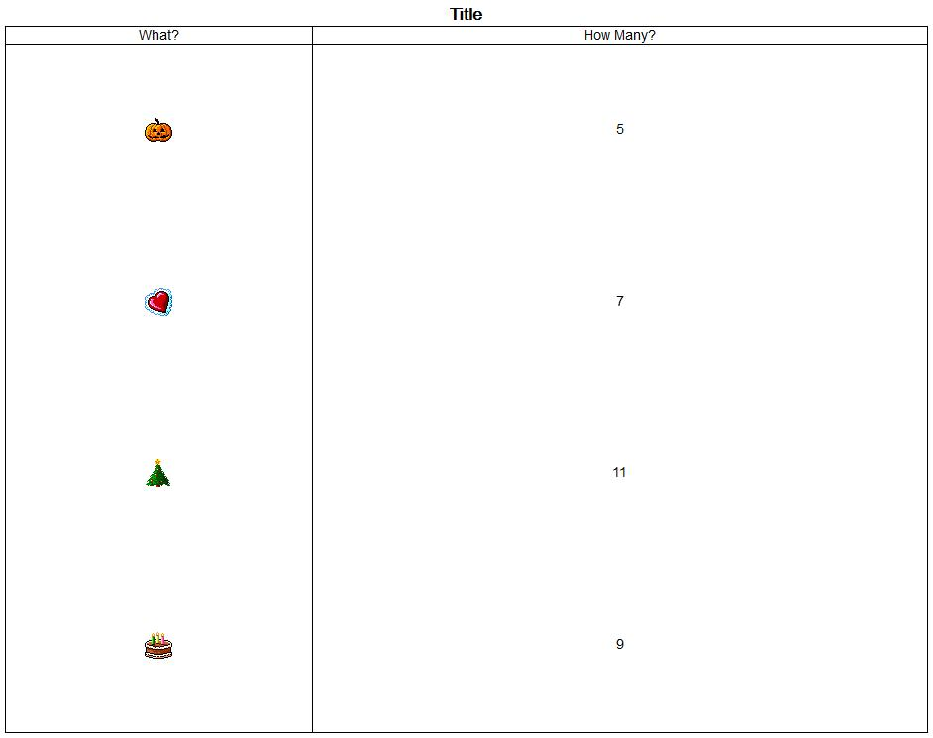
Other comments about your proposed spreadsheet/graph/chart activity: For extension, students can get a larger based opinion poll, such as all the baseball players in the school or all the female third graders, and use more options to create a more advance chart or graph.

